AWS CLOUD PROJECT
Auto-Scaling Application
with Application Load Balancer

Lab Environment: Vocareum AWS Sandbox

1. Project Overview
This project demonstrates the deployment of a highly available, auto-scaling web application on Amazon Web Services (AWS). The application automatically scales EC2 instances up or down based on traffic demand, using an Application Load Balancer (ALB) to distribute incoming requests.

1.1 Objectives
- Deploy a web application that can handle variable traffic loads
- Configure auto-scaling to automatically add/remove EC2 instances
- Use an Application Load Balancer to evenly distribute traffic
- Demonstrate production-level AWS architecture skills

1.2 AWS Services Used
AWS Service | Purpose
EC2 (Elastic Compute Cloud) | Virtual servers that run the web application
Application Load Balancer | Distributes incoming traffic across EC2 instances
Auto Scaling Group | Automatically adds/removes EC2 instances based on load
Launch Template | Defines the configuration for new EC2 instances
Security Groups | Controls inbound/outbound traffic (firewall rules)
Target Group | Routes requests to registered EC2 instances

2. Architecture Diagram
The following diagram illustrates the high-level architecture of this project:

Internet --> Application Load Balancer --> Auto Scaling Group
|
EC2 Instance 1
EC2 Instance 2
EC2 Instance N (auto-added)

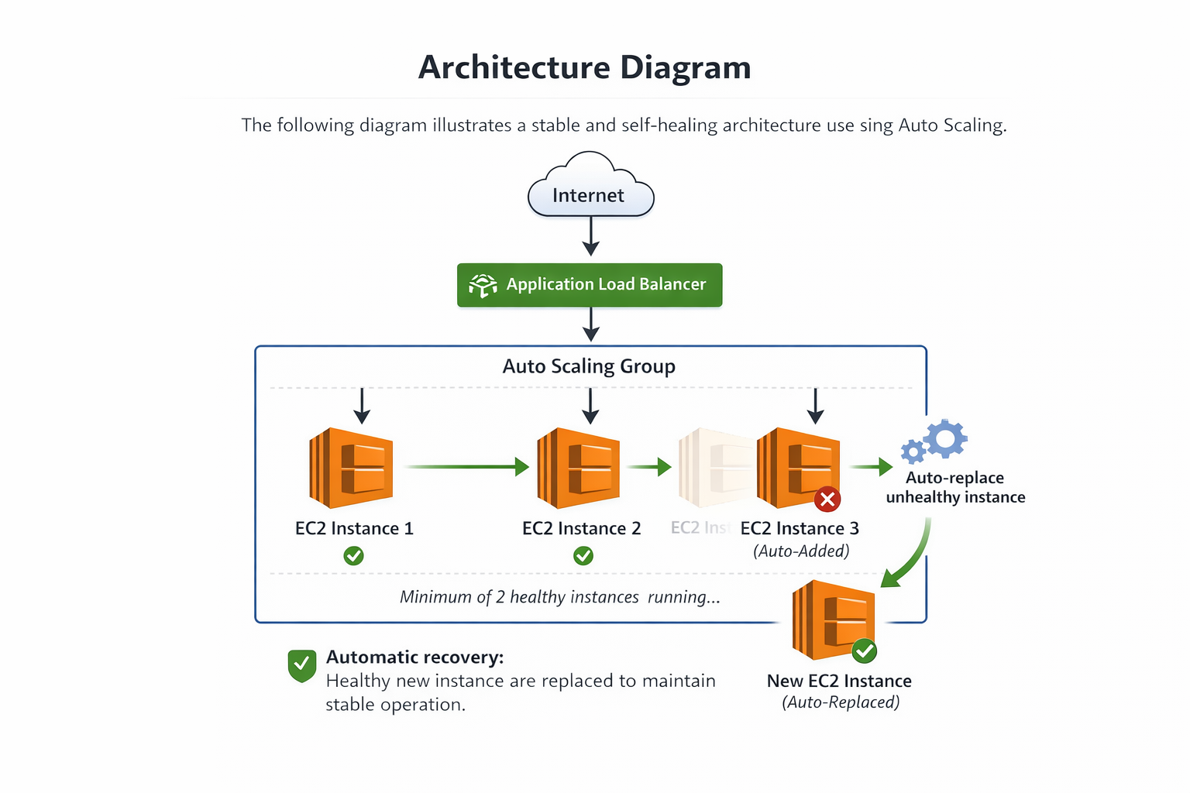

3. Step-by-Step Setup Instructions

Step 1: Create a Launch Template
A Launch Template defines what kind of EC2 instance to launch when scaling occurs.

- Go to AWS Console → EC2 → Launch Templates → Create Launch Template
- Set Launch template name: my-app-template
- Select AMI: Amazon Linux 2023 (Free Tier eligible)
- Select Instance type: t2.micro
- Select Key pair: vockey (provided by Vocareum)
- Create a new Security Group named my-app-sg with HTTP (port 80) and SSH (port 22) open
- Paste the following User Data script in Advanced Details:

#!/bin/bash
yum update -y
yum install -y httpd
systemctl start httpd
systemctl enable httpd
echo "<h1>Hello from $(hostname)</h1>" > /var/www/html/index.html
- Click Create launch template
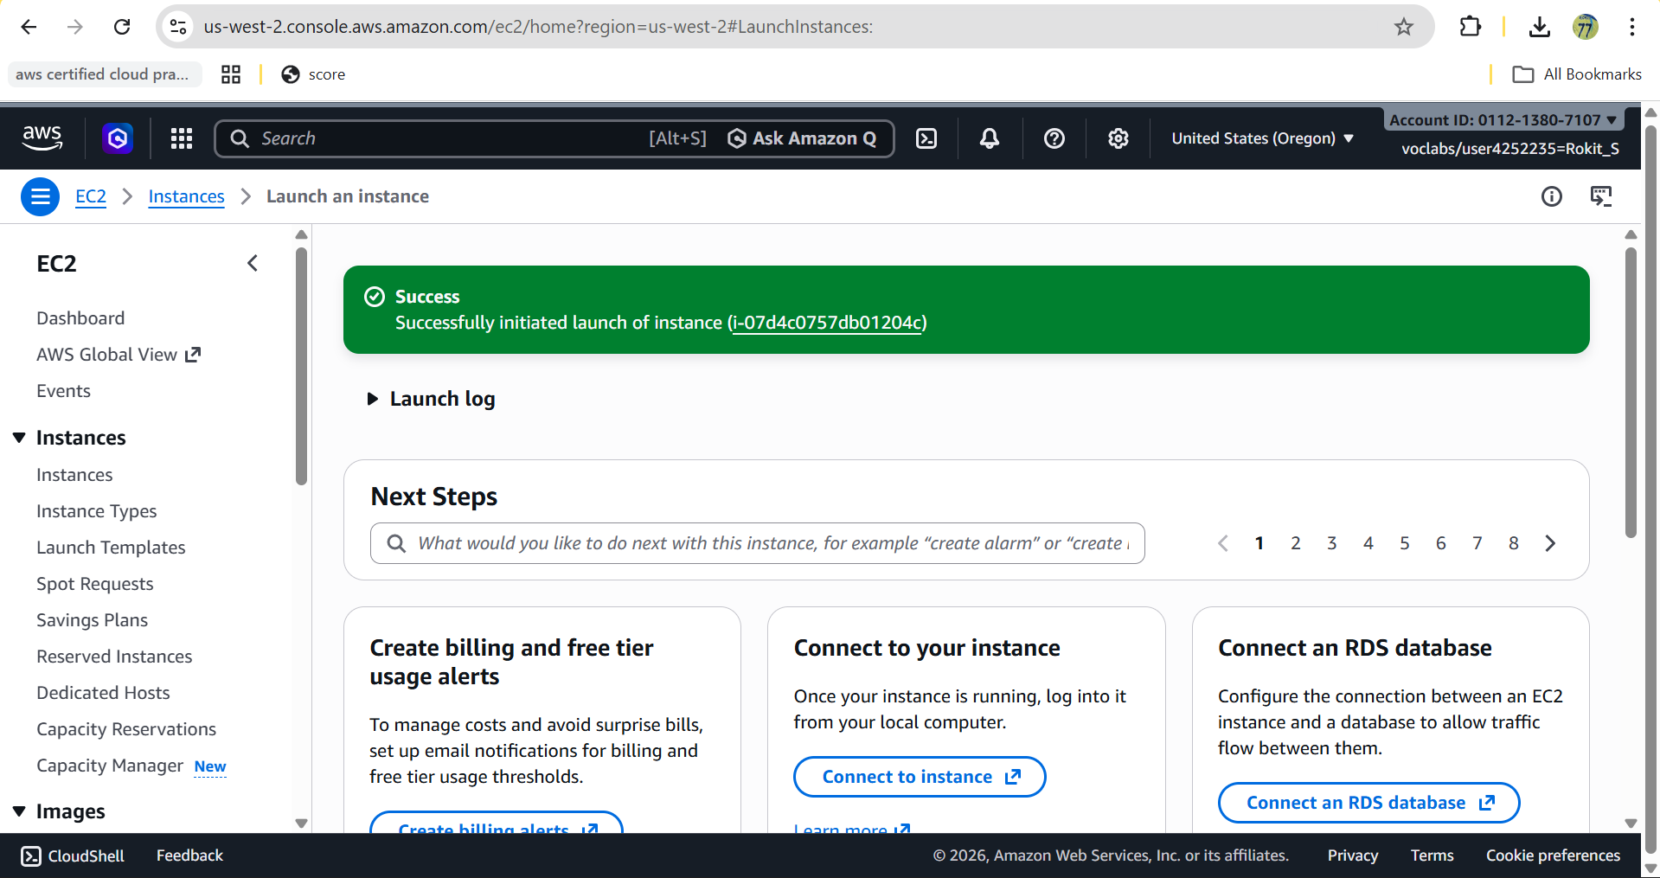

Step 2: Create a Target Group
The Target Group tells the Load Balancer which EC2 instances to send traffic to.

- Go to EC2 → Target Groups → Create target group
- Target type: Instances
- Target group name: my-app-tg
- Protocol: HTTP | Port: 80
- VPC: Select default VPC
- Health check path: /
- Click Next → then Create target group (do not add any instances manually)

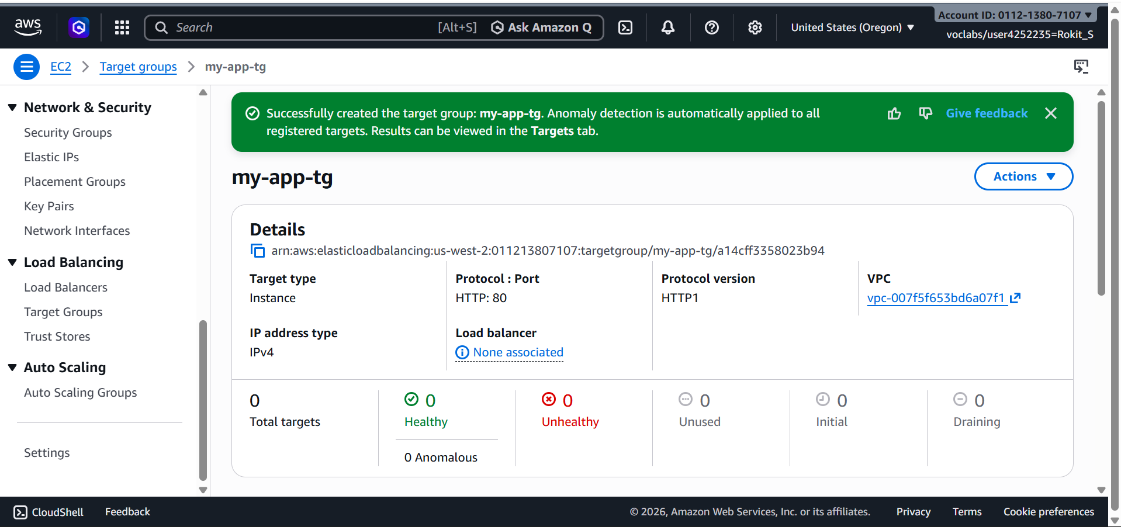

Step 3: Create an Application Load Balancer
The Load Balancer receives internet traffic and distributes it to your EC2 instances.

- Go to EC2 → Load Balancers → Create Load Balancer
- Choose: Application Load Balancer → Create
- Name: my-app-alb
- Scheme: Internet-facing | IP address type: IPv4
- Network mapping: Select all available Availability Zones
- Security group: Select my-app-sg
- Listener: HTTP port 80 → Forward to: my-app-tg
- Click Create load balancer

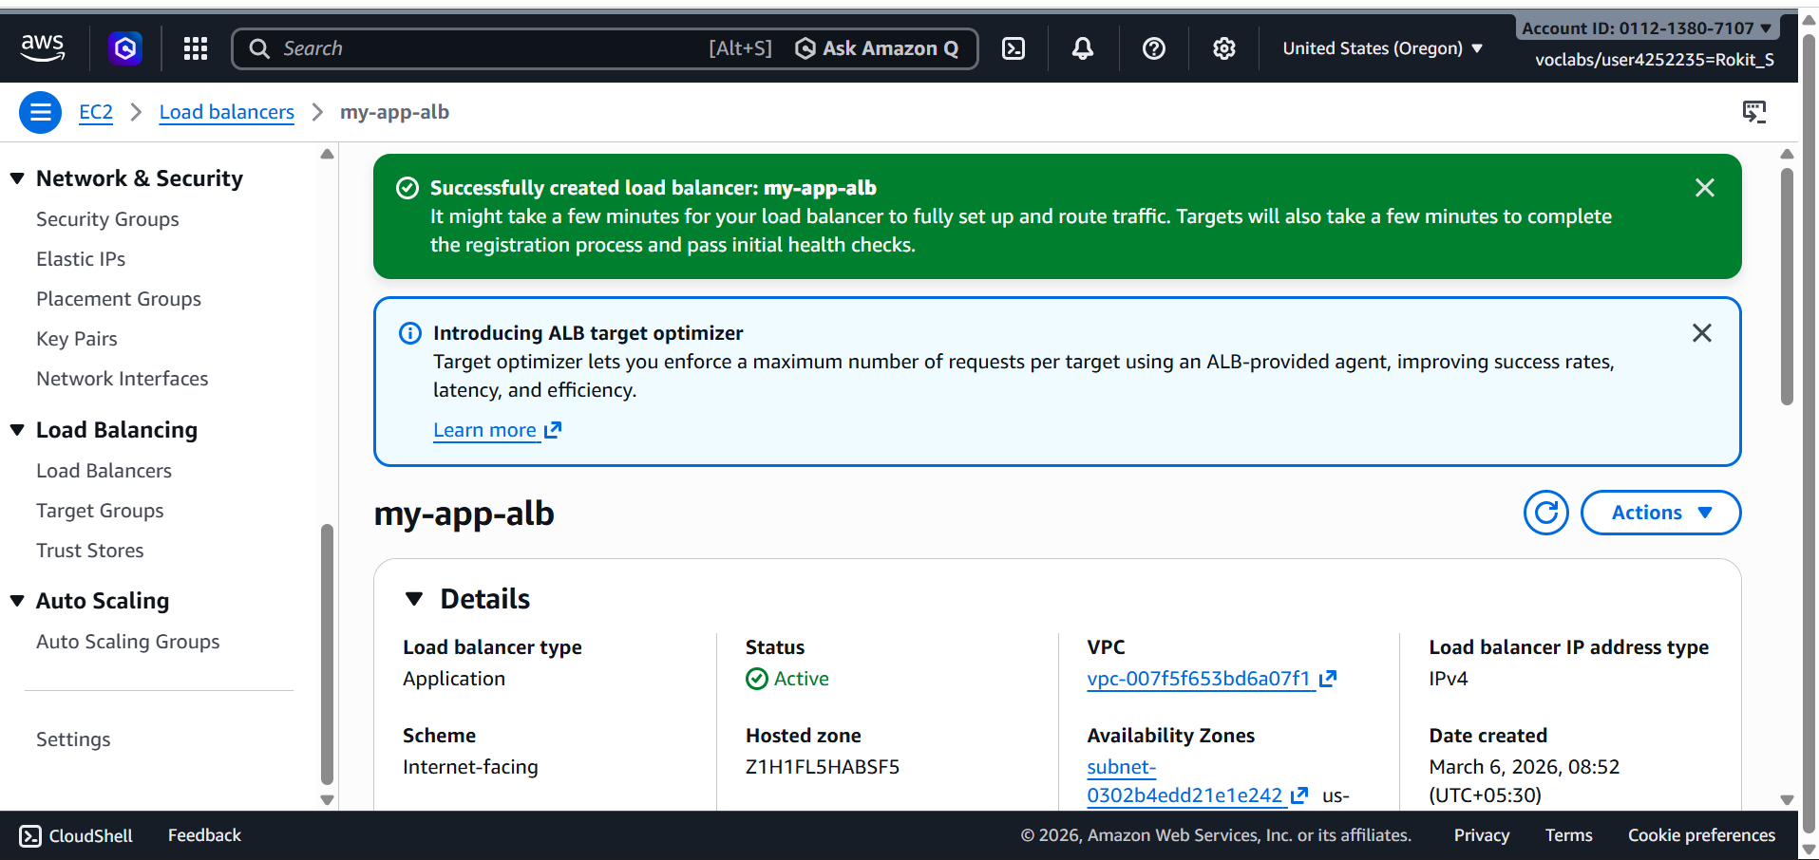

Step 4: Create an Auto Scaling Group
The Auto Scaling Group automatically launches or terminates EC2 instances based on demand.

- Go to EC2 → Auto Scaling Groups → Create Auto Scaling group
- Name: my-app-asg
- Launch template: my-app-template → Click Next
- VPC: Default VPC → Select all Availability Zones → Click Next
- Load balancing: Attach to an existing load balancer → my-app-tg
- Health checks: Enable ELB health checks → Click Next
- Set capacity: Desired: 2 | Minimum: 1 | Maximum: 4
- Scaling policy: Target tracking → CPU utilization → Target: 50%
- Click Skip to review → Create Auto Scaling group

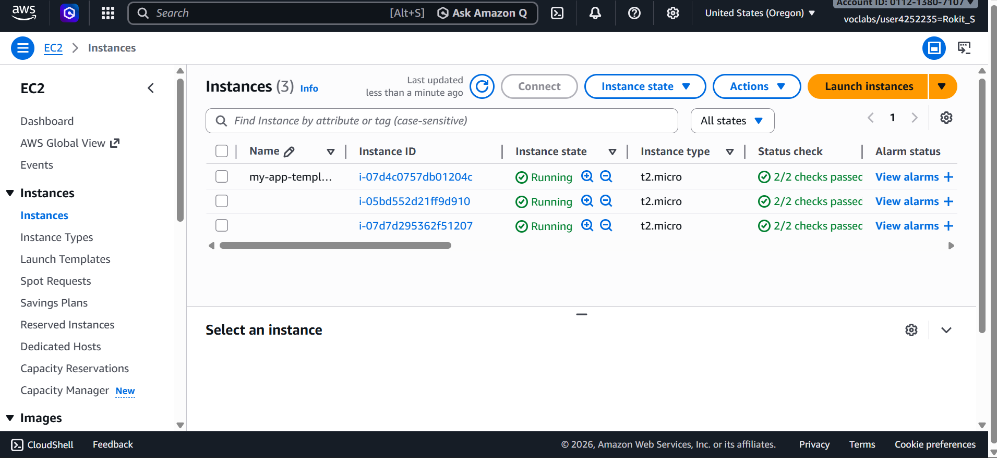

Step 5: Test the Application
Verify everything is working correctly.

- Go to EC2 → Load Balancers → Select my-app-alb
- Copy the DNS name (e.g. my-app-alb-xxxxxxxx.us-east-1.elb.amazonaws.com)
- Paste it in your browser → you should see: Hello from ip-xxx-xxx-xxx-xxx
- Refresh multiple times → notice the hostname changes (different EC2 instances responding)
- Go to EC2 → Instances → confirm 2 instances are running

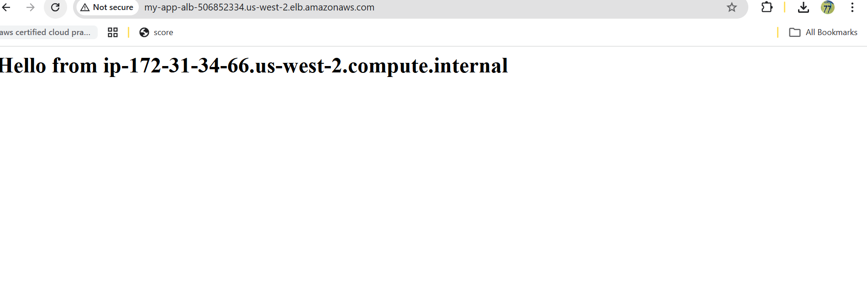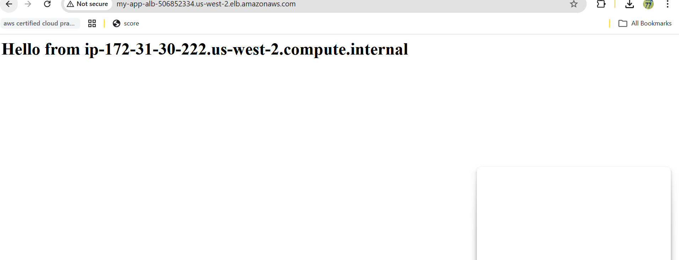

Step 6: Clean Up Resources
Important: Always delete resources after testing to avoid charges.

- Delete Auto Scaling Group (this terminates EC2 instances automatically)
- Delete Load Balancer
- Delete Target Group
- Delete Launch Template
- Delete Security Group: my-app-sg

4. Project Summary
Item | Detail
Project Name | Auto-Scaling Web App with Application Load Balancer
Cloud Provider | Amazon Web Services (AWS)
Lab Environment | Vocareum AWS Sandbox
Region | us-east-1 (N. Virginia)
Instance Type | t2.micro (Free Tier)
Min Instances | 1
Max Instances | 4
Scaling Trigger | CPU Utilization > 50%

Key Concepts Demonstrated
- High Availability: Application stays online even if one EC2 instance fails
- Elasticity: System automatically scales up under high traffic, scales down when quiet
- Load Balancing: Traffic evenly distributed across multiple servers
- Infrastructure as Code: EC2 configuration stored in Launch Template
- Health Checks: Load Balancer automatically removes unhealthy instances

AWS Vocareum Sandbox Lab

